Weather station and thermostat
The project we made is a simple weather station, reading the temperature and displaying it on a 7-segment display with 4 digits, with a precision of 0.1 degrees Celsius. The temperature is sensed by an NTC resistor, coupled to a voltage divider to get a voltage reading between 0 and 5 volts. The second mode of the circuit is a thermostat, the green LED turns on when the set temperature is above the ambient temperature, signifying heating mode, and the blue LED is turned on when the set temperature is below the ambient temperature, signifying cooling mode. A potentiometer is used to set the reference temperature in the thermostat mode. We had an attempt to monitor the RPM of a fan, and the second potentiometer is used to vary the speed of this fan, but due to limitations of our Arduino board, we could not implement this feature. We wanted to use a Hall Effect sensor to sense the rotation of this fan, we can see that the sensor works but it’s status LEDs.
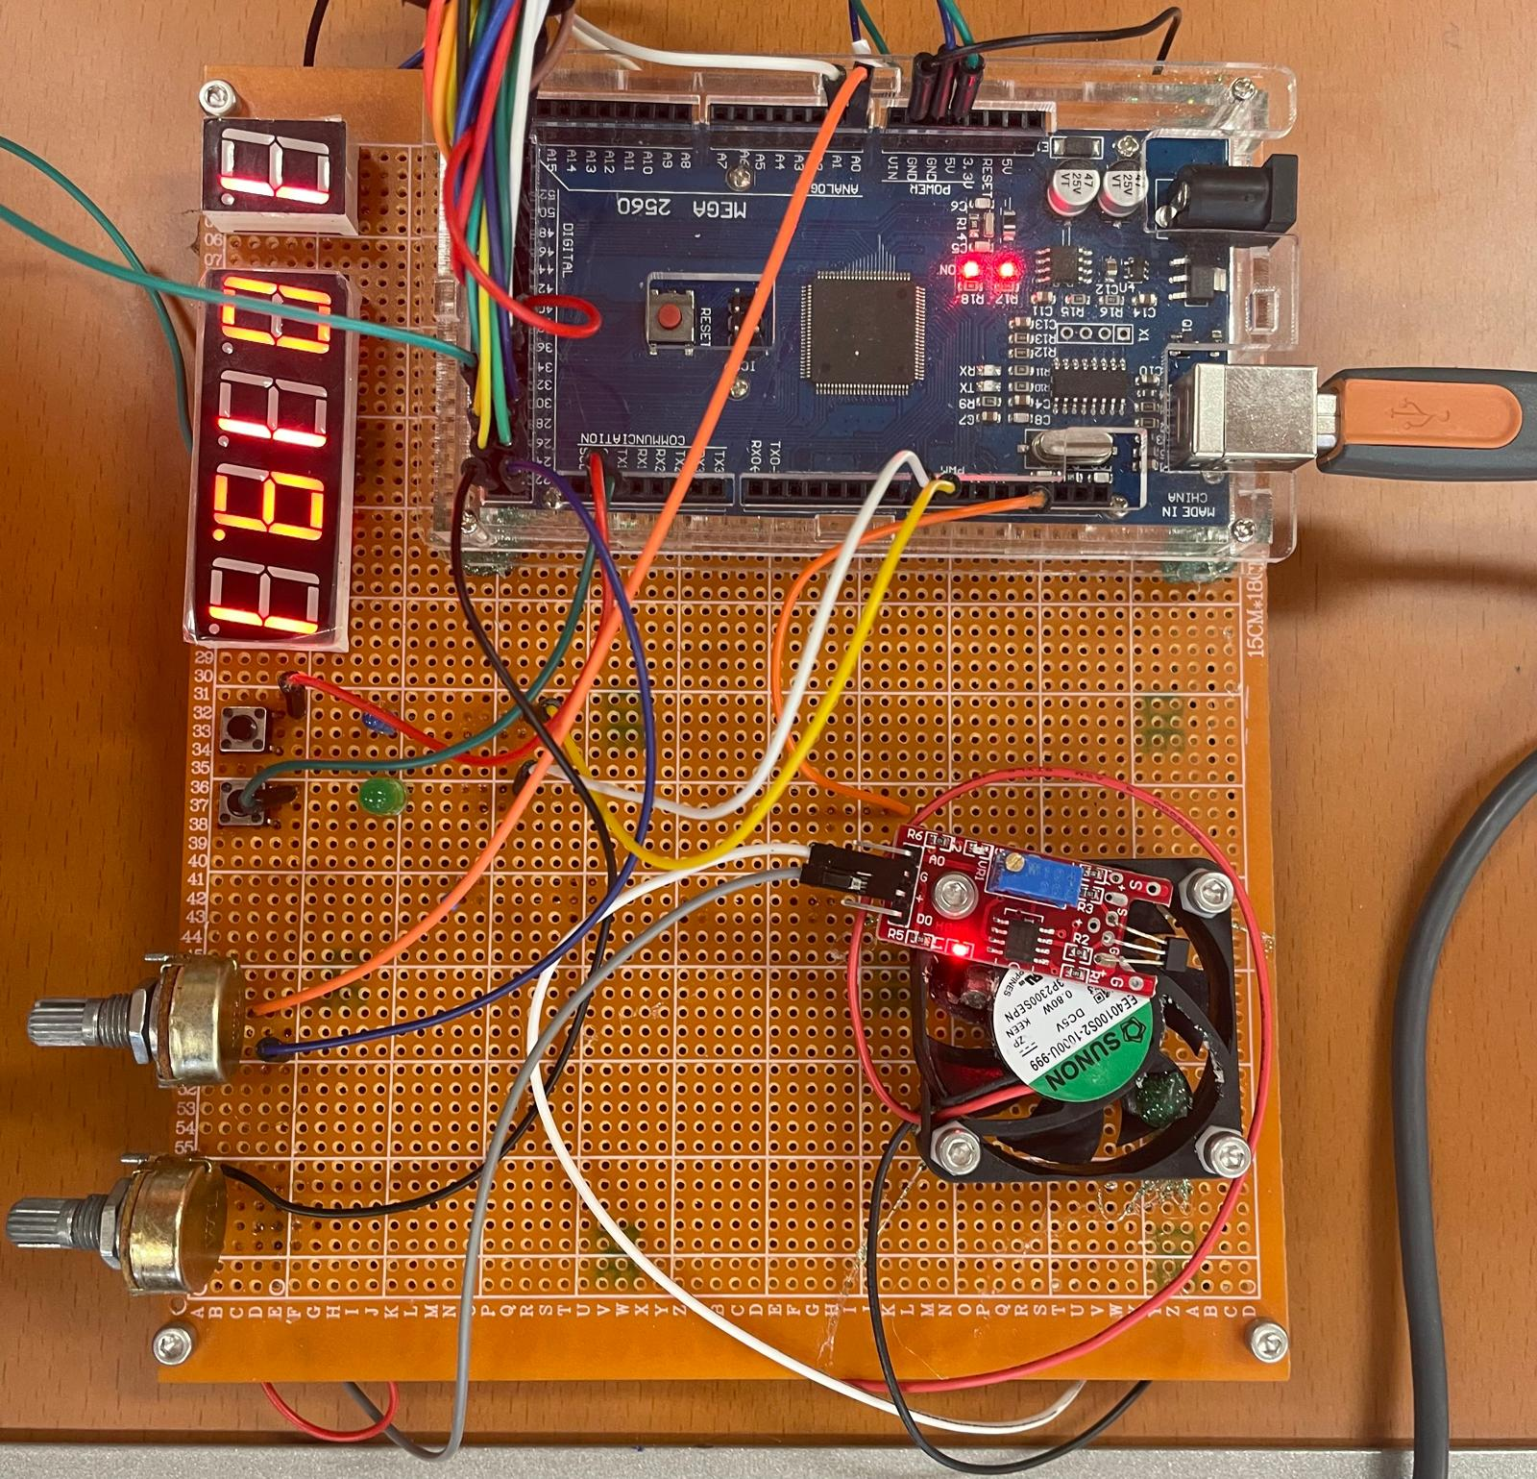
Sensors and actuators:
NTC thermistor
Hall effect
2 LEDs
7 segment displays
2 pots
1 button
1 fan
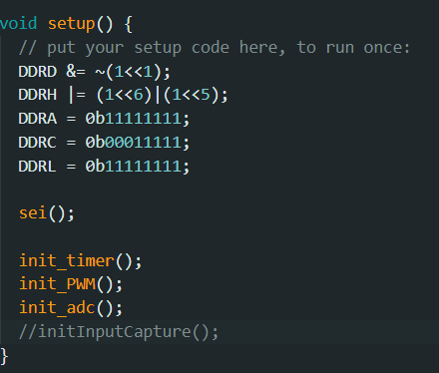
We are using registers in order to make the code as efficient as possible, no built-in functions from the Arduino family

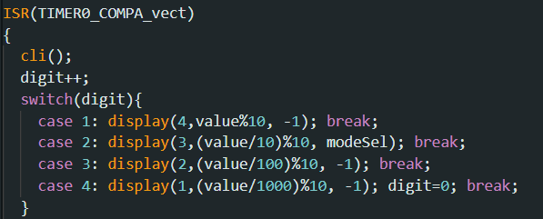
Here is a small part of the Interrupt Routine for Timer 1 which is controlling the displays, switching between the 4 digits each ms.

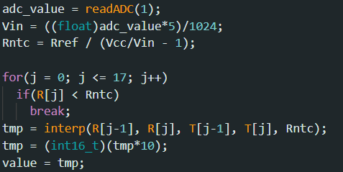
This piece of code highlights how the NTC voltage value is converted into temperature, using linear interpolation (the function interp).

